3a
- My program can save or withdraw money and predict or get profit to individuals by their own choice.
- The program offers functions including registration, logging in, depositing, withdrawing, checking balance, and choosing interest rates. And the interest function including calculation function.
- I entered an incorrect password while creating an account, which led to an error. After correcting my password, I logged in and found my balance was zero. I deposited 3000 and attempted to withdraw 100000, but received an error message due to insufficient funds. I then withdrew 1000, leaving a balance of 2000. Selecting the fifth interest option and inputting a 10-year deposit period, the system predicted that I would have 2400. After confirming this option, my balance became 2400 after 10 years. I tried the second interest option, which predicted a deposit of 3360, but didn't confirm and my balance remained the same. Upon selecting the eighth interest option, I received an error message for incorrect input.

3b
1.
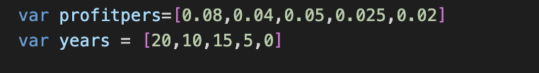
2.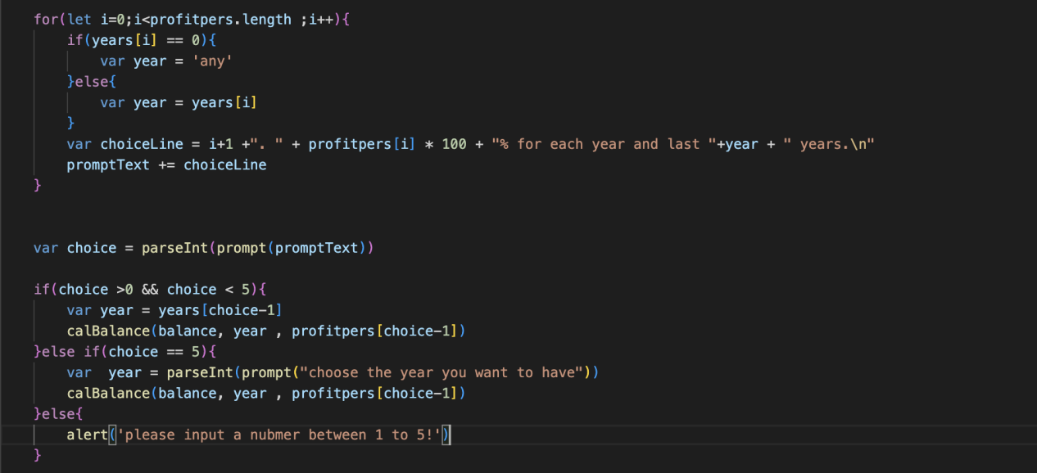

- profitpers, years
- In the list profitpers, the value contained is about interest rate. And in the list years, the value contained is about years that interest choice has.
- If I choose not to use a list of years, I will need to write the same line of code repeatedly for every year in order to calculate certain values. However, by utilizing a list of years, I can avoid having to write this repetitive code and instead can reuse the same code block to calculate the necessary values for each individual year. Similarly, when it comes to the profitpers list, if I decide not to use it, I will be required to write out the same code repeatedly for each choice that a user makes in order to calculate the profit they earn. However, if I take advantage of the profitpers list, I can reuse the same code block to calculate the profits for each choice, based on the values in the list, thereby avoiding the need for repetitive coding.

3c
1.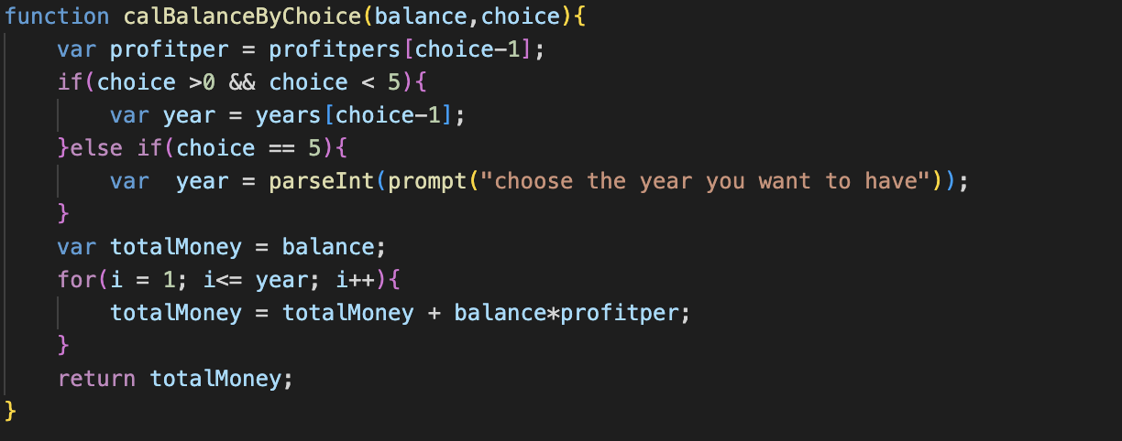

2.
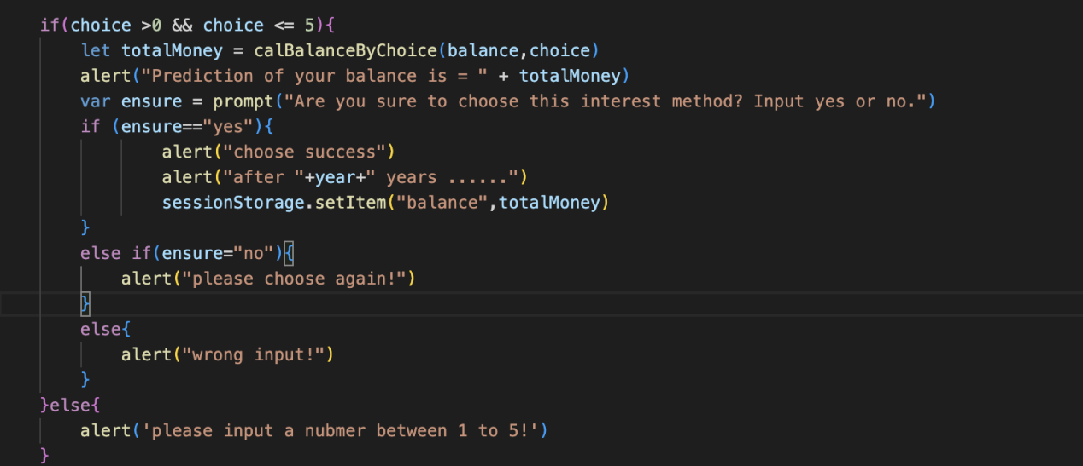

- The calBalance function is a crucial aspect of the program, serving as a calculation process for determining the profit that users can earn based on their chosen interest rates. By consolidating this calculation process within a single function, the overall functionality of the program is significantly improved. This not only simplifies the code, but also minimizes the need for repetitive sentences throughout the program. As a result, the code becomes easier to read and more convenient to write, ultimately helping to achieve the program's primary goal of calculating the profit that users can expect to earn.
- In this function, the parameters 'balance’ and ‘choice’ are retrieved from the preceding code. According to the choice that users choose, the different profit per year and year will be define. If the choice is 5 which is the current profit, the year would be defined by users’ inputs. And there is a new variable called totalMoney which is equal to the balance that stored in the system. And there is a for loop and a formula to calculate the total money that the user can have after the calculation. And the function will return this total money as totalMoney

3d

(1)The first call is that if a user input the choice that between 1-4, the variable year would be got from the list in the previous code, and execute the calculation of total money to get the money after using the interest rate choice by users, and return this variable back.

(2)The second call is that if a user input the choice 5, the variable year would be got from users input, and execute the calculation of total money to get the money after using the interest rate choice by users.

2.
- When user wants annual interest rate choice 1, and the balance is 10000, the first call will be executed.
- When user wants annual interest rate choice 5, and the balance is 10000, the second call will be executed.
3.
- After the calculation by the system, the result or the return variable totalMoney will be 26000.
- After the calculation by the system, and the input of the year that user want is 10 years, the result or the return variable totalMoney will be 12000.

